 **Year 7 Angles make a difference**

Name: _________________

Class: _____________

**Weighting: 20%**

**Total marks 24**

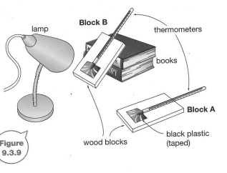

**/24**

**Variables**

Independent variable: **(1 mark)**

**Angle to the lamp**

Dependent variable: **(1 mark)**

**Temperature**

2 controlled variables:  **(2 marks)**

**Either same lamp source, same location, same brand of thermometer, same size wood block, same size or thickness of black plastic**

**Hypothesis: (2 marks)**

**If the angle is greater then the temperature will increase because the light is more concentrated/direct 1 for independent/dependent (1/2each) 1 mark for reasonable explanation**

**Results:** Complete the table by entering the relevant heading titles and units where needed. **(2 marks)**

|  |  |  |
| --- | --- | --- |
| Time (min) | Temperature (1 Mark) (OC) (1 mark) | |
| Block B | Block A |
| 1 | 12 | 5 |
| 2 | 34 | 10 |
| 3 | 52 | 15 |
| 4 | 70 | 20 |
| 5 | 86 | 25 |

Use the graph paper provided to draw a graph of the results plotting time vs temperature on the appropriate axis (8 marks)

|  |  |
| --- | --- |
| Graphs data collected from the investigation (if applicable): | |
| provides appropriate graph title (0.5/0.5) | |
| labels axes correctly(0.5/0.5) |
| includes appropriate units of measurement (0.5/0.5) | |
|
| plots data correctly 2 mark for all 10 plots correct  1.5 marks if 1-3 plots wrong  1 mark 4- 5 wrong  0.5 mark 6-7 incorrect  0 marks if 8- 10 incorrect |
| draws the appropriate type of graph. (1)  Key for both lines labelled (1)  Ruler (1) | |
|  | |

**Discussion:**

Identify which block showed the greatest increase in temperature (1 mark)

Block B

Identify which block modelled the surface area of the Earth in : (1 mark)

1. Far north Queensland B
2. Southern Tasmania A

Use your results to explain why (6 marks)

1. the tropics are found near the equator
2. icebergs are only found near the poles

The equator is a place where the sunlight falls directly on the Earth ( 1 mark) and therefore the Tropics is very hot (1 mark) because the sunlight is concentrated (1 mark).

The North and South Pole are the coldest parts of the planet (1 mark) and this is why icebergs only occur there. Any sunlight that falls on the area is almost parallel to the Earth’s surface (1 mark) and the sunlight is spread out over a large area (1 mark)